UID II
EX NO : 3
1.Command Line Interface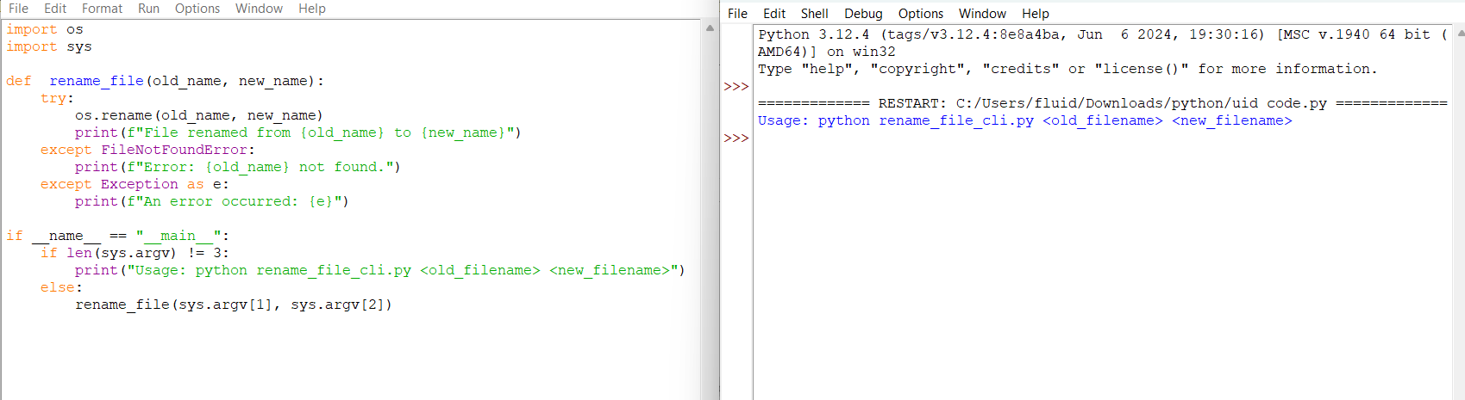

2.Graphical User Interface
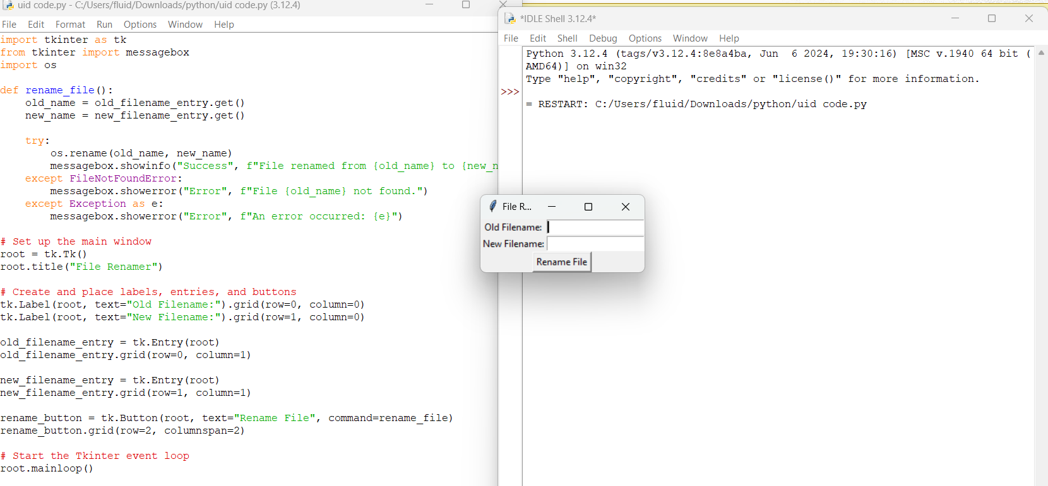

3.Voice User Interface
